**Name – Himanshu verma , Bsc (Hons) Electronics**

**Roll no. - 230416**

**ACHARYA NARENDRA DEV COLLEGE (DU)**

**PROJECT : Food Order Prediction**

**# output** , **please** look into the **last page**

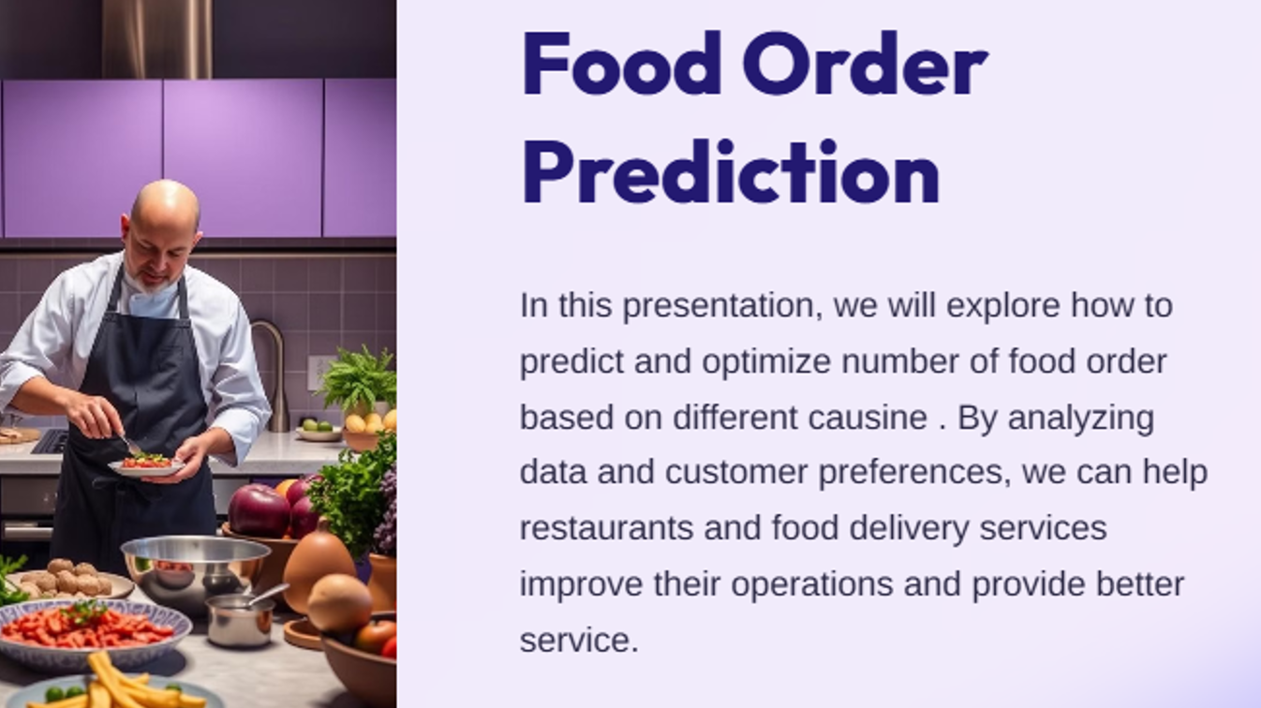

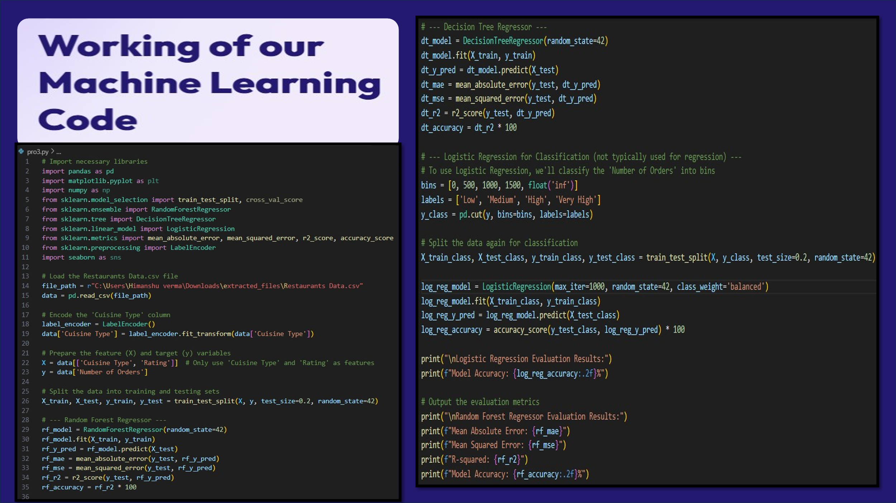

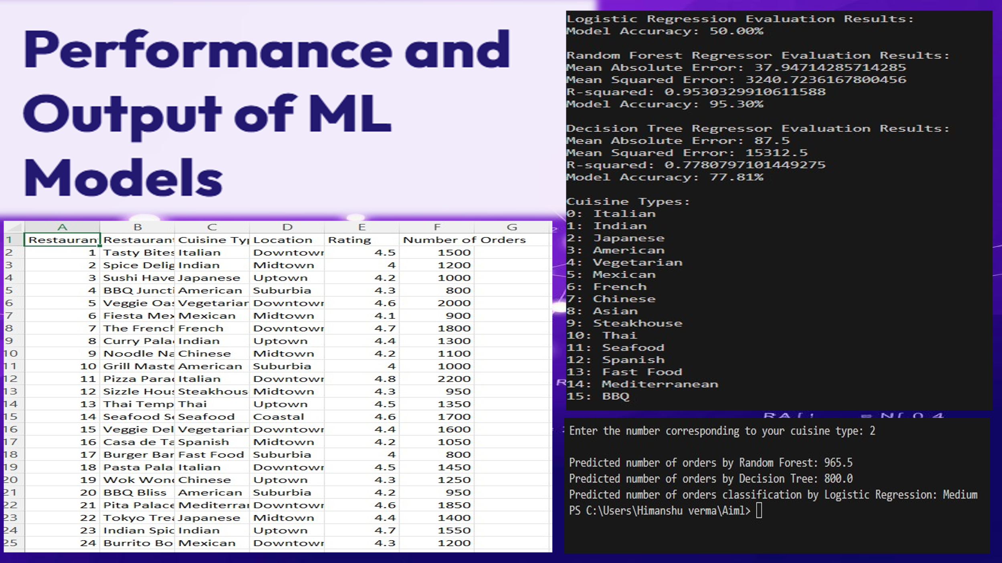

**# output , please look into the last page**

**Code:**

# Import necessary libraries

import pandas as pd

import matplotlib.pyplot as plt

import numpy as np

from sklearn.model_selection import train_test_split, cross_val_score

from sklearn.ensemble import RandomForestRegressor

from sklearn.tree import DecisionTreeRegressor

from sklearn.linear_model import LogisticRegression

from sklearn.metrics import mean_absolute_error, mean_squared_error, r2_score, accuracy_score

from sklearn.preprocessing import LabelEncoder

import seaborn as sns

# Load the Restaurants Data.csv file

file_path = r"C:\Users\Himanshu verma\Downloads\extracted_files\Restaurants Data.csv"

data = pd.read_csv(file_path)

# Encode the 'Cuisine Type' column

label_encoder = LabelEncoder()

data['Cuisine Type'] = label_encoder.fit_transform(data['Cuisine Type'])

# Prepare the feature (X) and target (y) variables

X = data[['Cuisine Type', 'Rating']]  # Only use 'Cuisine Type' and 'Rating' as features

y = data['Number of Orders']

# Split the data into training and testing sets

X_train, X_test, y_train, y_test = train_test_split(X, y, test_size=0.2, random_state=42)

# --- Random Forest Regressor ---

rf_model = RandomForestRegressor(random_state=42)

rf_model.fit(X_train, y_train)

rf_y_pred = rf_model.predict(X_test)

rf_mae = mean_absolute_error(y_test, rf_y_pred)

rf_mse = mean_squared_error(y_test, rf_y_pred)

rf_r2 = r2_score(y_test, rf_y_pred)

rf_accuracy = rf_r2 * 100

# --- Decision Tree Regressor ---

dt_model = DecisionTreeRegressor(random_state=42)

dt_model.fit(X_train, y_train)

dt_y_pred = dt_model.predict(X_test)

dt_mae = mean_absolute_error(y_test, dt_y_pred)

dt_mse = mean_squared_error(y_test, dt_y_pred)

dt_r2 = r2_score(y_test, dt_y_pred)

dt_accuracy = dt_r2 * 100

# --- Logistic Regression for Classification (not typically used for regression) ---

# To use Logistic Regression, we'll classify the 'Number of Orders' into bins

bins = [0, 500, 1000, 1500, float('inf')]

labels = ['Low', 'Medium', 'High', 'Very High']

y_class = pd.cut(y, bins=bins, labels=labels)

# Split the data again for classification

X_train_class, X_test_class, y_train_class, y_test_class = train_test_split(X, y_class, test_size=0.2, random_state=42)

log_reg_model = LogisticRegression(max_iter=1000, random_state=42, class_weight='balanced')

log_reg_model.fit(X_train_class, y_train_class)

log_reg_y_pred = log_reg_model.predict(X_test_class)

log_reg_accuracy = accuracy_score(y_test_class, log_reg_y_pred) * 100

print("\nLogistic Regression Evaluation Results:")

print(f"Model Accuracy: {log_reg_accuracy:.2f}%")

# Output the evaluation metrics

print("\nRandom Forest Regressor Evaluation Results:")

print(f"Mean Absolute Error: {rf_mae}")

print(f"Mean Squared Error: {rf_mse}")

print(f"R-squared: {rf_r2}")

print(f"Model Accuracy: {rf_accuracy:.2f}%")

print("\nDecision Tree Regressor Evaluation Results:")

print(f"Mean Absolute Error: {dt_mae}")

print(f"Mean Squared Error: {dt_mse}")

print(f"R-squared: {dt_r2}")

print(f"Model Accuracy: {dt_accuracy:.2f}%")

# List of available cuisine types

cuisine_types = {

    0: 'Italian', 1: 'Indian', 2: 'Japanese', 3: 'American', 4: 'Vegetarian', 5: 'Mexican', 6: 'French', 7: 'Chinese',

    8: 'Asian', 9: 'Steakhouse', 10: 'Thai', 11: 'Seafood', 12: 'Spanish', 13: 'Fast Food', 14: 'Mediterranean', 15: 'BBQ'

}

# Display the list of cuisine types with corresponding numbers

print("\nCuisine Types:")

for key, value in cuisine_types.items():

    print(f"{key}: {value}")

# User input for prediction

cuisine_input = int(input("\nEnter the number corresponding to your cuisine type: "))

# Create a DataFrame for prediction

user_input_df = pd.DataFrame({

    'Cuisine Type': [cuisine_input],

    'Rating': [0]  # Dummy value

})

# Predict using Random Forest

rf_user_pred = rf_model.predict(user_input_df)

print(f"\nPredicted number of orders by Random Forest: {rf_user_pred[0]}")

# Predict using Decision Tree

dt_user_pred = dt_model.predict(user_input_df)

print(f"Predicted number of orders by Decision Tree: {dt_user_pred[0]}")

# Predict using Logistic Regression

log_reg_user_pred = log_reg_model.predict(user_input_df)

print(f"Predicted number of orders classification by Logistic Regression: {log_reg_user_pred[0]}")

output:

